**UNIX COMMAND**

**DOCUMENT**

Version: 1.2

DB Schenker

TSC-Nanjing

GIeS SWORD

UNIX Group

Contents

1. Monitoring Scripts 3

1.1 Clean_up2 3

1.2 list2 4

1.3 remafi 9

1.4 Crontab 11

1.5 Largefile agreements in ftp server 12

2. Functionality Scripts 13

2.1 Connection test 13

2.2 How to login for ftp/sftp/ftps 15

2.3 agrgrep 16

2.4 fzbf2 17

2.5 agrc/cdagr 18

2.6 check_trace_log_age 19

2.7 eless/ecat/ales/ xless 20

2.8 showloggersize 21

2.9 showqueuelengths 22

2.10 showactiveagreements 23

2.11 Count file numbers in sub folder 24

2.12 split and resend big file 25

| **Date** | **Version** | **Update** | **Comment** |
| --- | --- | --- | --- |
| 25.07.2017 | 1.0 | JaneZ | Creation by JaneZ, JasonJ, LeoS, BillyL |
| 28.9.2017 | 1.1 | BillyL | Review and edit the format. |
| 16.1.2018 | 1.2 | AllenC | Add information about script “mysplit.sh” |

1. **Monitoring Scripts**
   1. **Clean_up2**
      1. **Name**

Clean_up2

* + 1. **Can be used on**

App Servers and GW Servers

* + 1. **Functionality**

Recognize then move files that confirmed by customer or historical tickets, and could be ignored to corresponding directories

Parameter –v: display which files have been moved

* + 1. **Details**

Each server has its specific files that could be clean up directly, so these scripts varies from servers

* + 1. **Example**

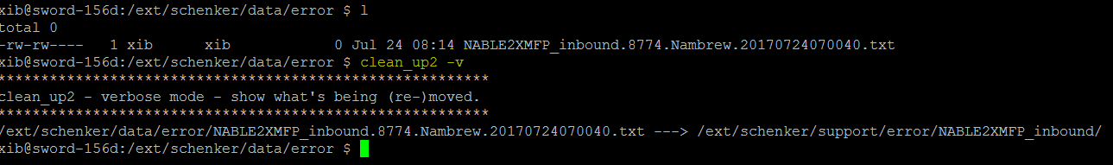

* + 1. **Note (How to add new items)**

If there are some new files that confirmed by customer could be housekeeping directly, as SOWRD AO, we could have an assessment and manually code the corresponding file to clean_up2 script.

For exemplification, after confirmation with customers in ticket INC000000736799, the 0-byte files from agreement CCMPESICPR_EUR_DB_inbound could be housekeeping directly, then we could add to lines to clean_up2

Line 1: to clarify which ticket does this Housekeeping actions refer to

#INC000000736799

Line2: to call the defined function ‘move_zero_byte_files’ to move the files with file name ‘CCMPESICPR_EUR_DB_inbound*’ from $ERR folder to ‘$SUPERR/CCMPESICPR_EUR_DB_inbound/’ folder

move_zero_byte_files "$ERR" "CCMPESICPR_EUR_DB_inbound*" "$SUPERR/CCMPESICPR_EUR_DB_inbound/"

* 1. **list2**
     1. **Name**

list2

* + 1. **Can be used on**

App Servers and GW Servers

* + 1. **Functionality**

List folder file info with oldest and recent one. Mostly we used on GW and FTP server.

GW: Comsys Directories; Outbound Agreement Directories; Inbound Agreement Directories

APP: System Directories

FTP: ComSys / ComSysPX directories; Customer directories (DOWNLOAD and UPLOAD)

* + 1. **Details**



* + 1. **Parameter**

a. -fileagemin=xx : Can be used on APP 1-4 GW 1-4. List the files older than specific minutes. eg. list2 -fileagemin=30 will list the files that older than 30 minutes.

b. –runbycron : Can be used on FTP server. List the files older than specific minutes. A quarter hour for download files; four days for outbound files.

* + 1. **Example**

a. list2

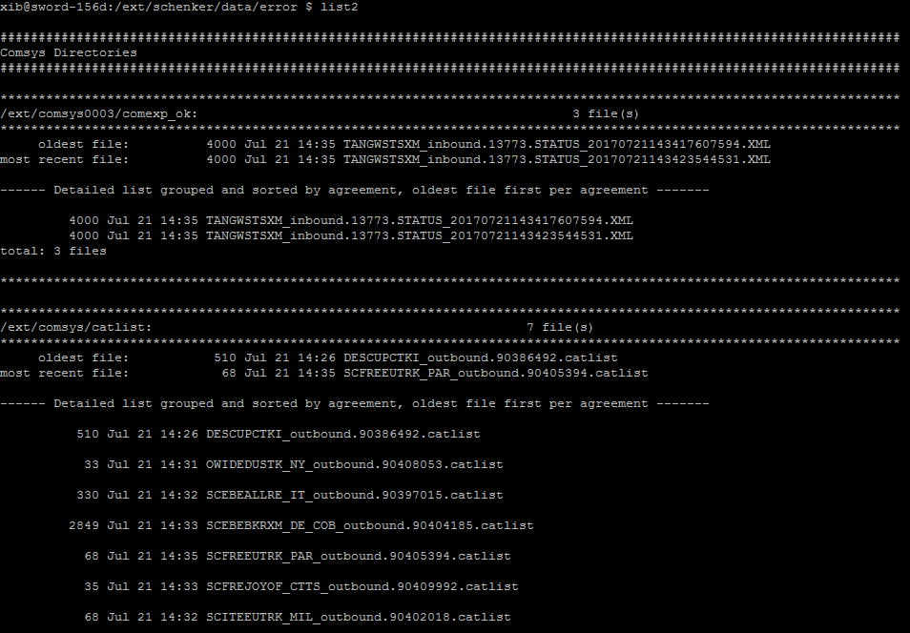

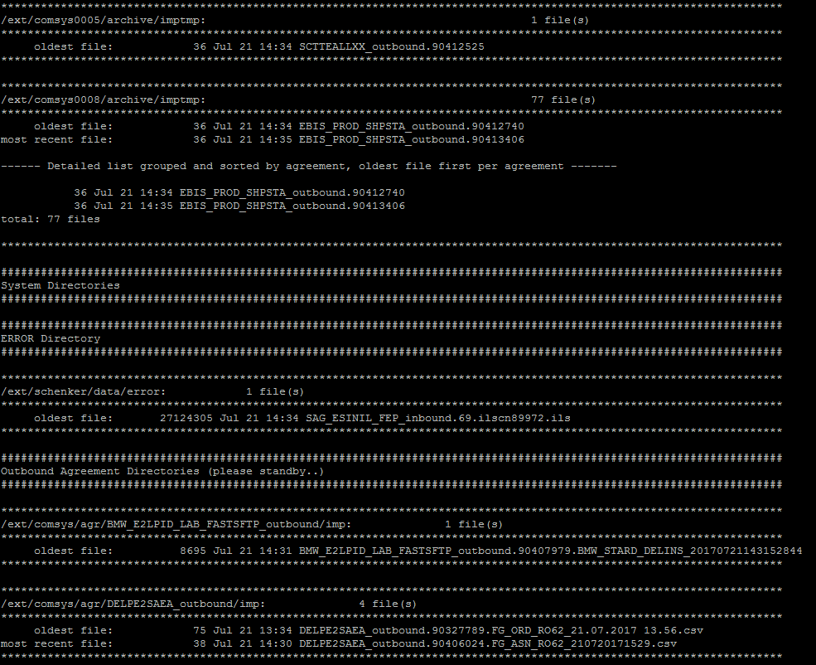

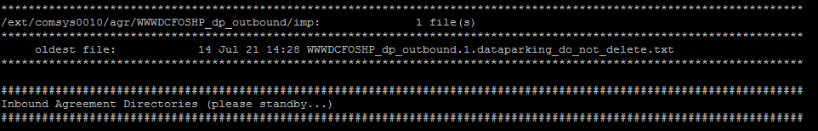

b. list2 -fileagemin=xx

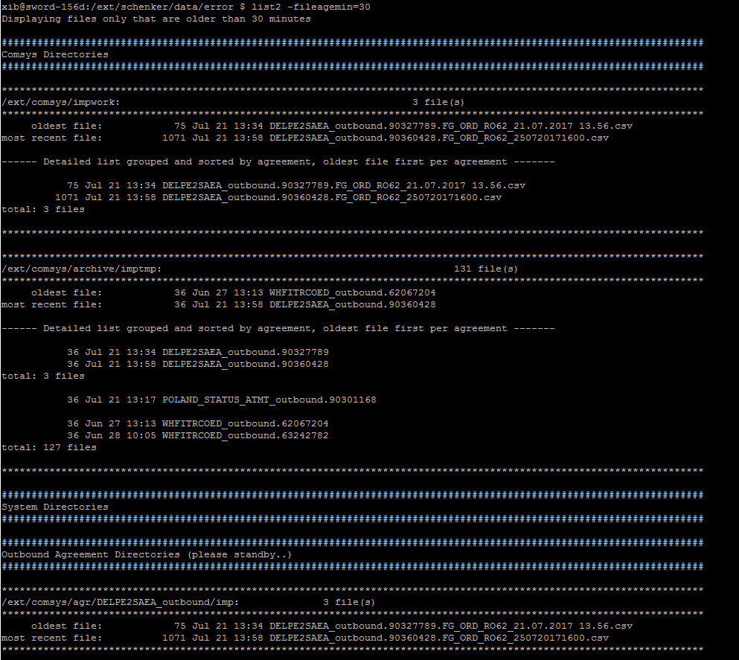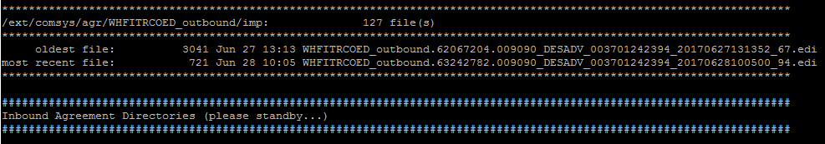

c. list2 –runbycron

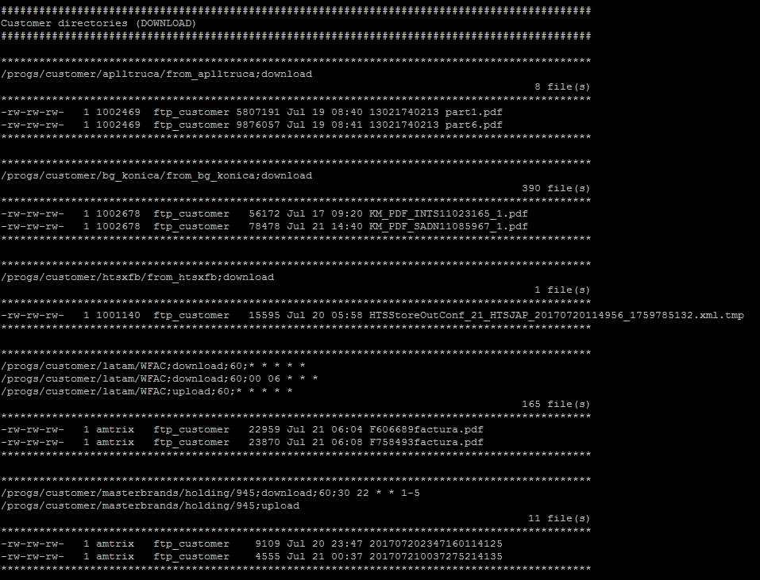

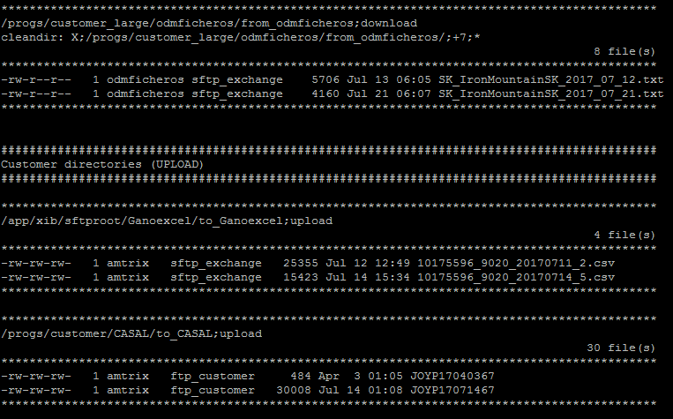

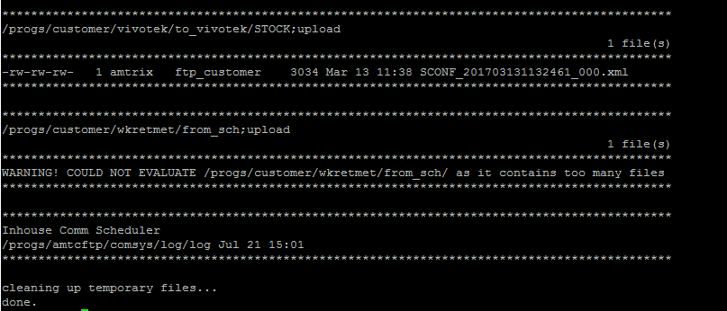

* 1. **remafi**
     1. **Name**

remafi

* + 1. **Can be used on**

APP 1-4

* + 1. **Functionality**

Resent files which reach the massfilter value. Too many or too big

For serial one we always set sleep time to 7.

For parallel one we always set sleep time to 1.

* + 1. **Details**

remafi <ProcessID> <sleep time> (sleep time is 1~300) 

* + 1. **Example**

Parallel:

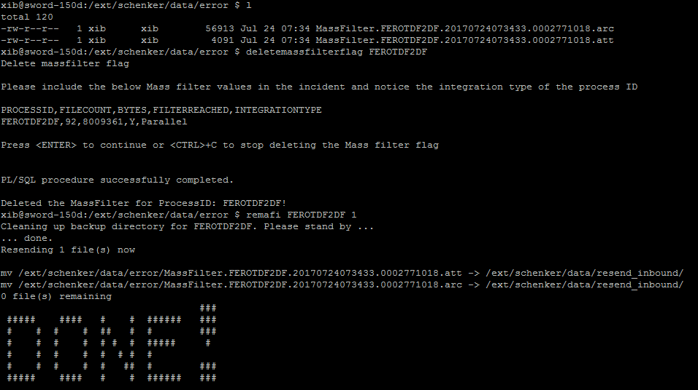

Serial:

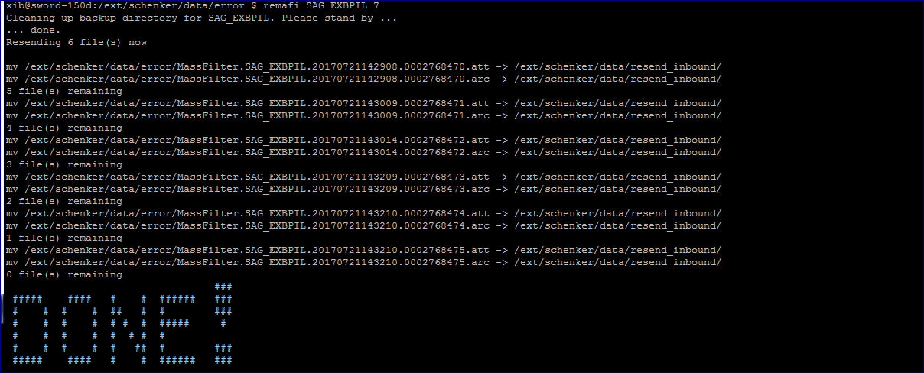

* 1. **Crontab**
     1. **Name**

Crontab

* + 1. **Can be used on**

In all streams

* + 1. **Functionality**

Scheduler jobs

a. Crontab –l : This used to list Cron jobs on server.

b. Crontab –e : This used to edit Cron jobs on server.

* + 1. **Details**

This example runs a shell program called export_dump.sh at 20:00 every day.

0 20 * * * /home/oracle/scripts/export_dump.sh

Configuration file

# * * * * * command to execute

# │ │ │ │ │

# │ │ │ │ │

# │ │ │ │ └───── day of week (0 - 6) (0 to 6 are Sunday to Saturday, or use names; 7 is Sunday, the same as 0)

# │ │ │ └────────── month (1 - 12)

# │ │ └─────────────── day of month (1 - 31)

# │ └──────────────────── hour (0 - 23)

# └───────────────────────── min (0 - 59)

* + 1. **Example**

[xib@sword-166d:~]$ crontab -l | less

ld.so.1: crontab: warning: /usr/lib/extendedFILE.so.1: open failed: illegal insecure pathname

# Swing events

0,5,10,15,20,25,30,35,40,45,50,55 * * * * [ -d /ext/xib ] && /ext/schenker/tools/ComsysSWINGEvents.pl >> /app/xib/ext/schenker/prot/cronlog/xib_cronlog.dat 2>&1

# SET STATE OF FILER FILES, DELETE UNUSED FILES

0 1 * * * [ -d /ext/xib ] && /ext/schenker/toolslocal/filerutil.sh 3 >> /app/xib/ext/schenker/prot/cronlog/xib_cronlog.dat 2>&1

0 2 * * * [ -d /ext/xib ] && /ext/schenker/toolslocal/filerutil.sh 3 /ext/xib/data/filer_parallel >> /app/xib/ext/schenker/prot/cronlog/xib_cronlog.dat 2>&1

0 3 * * * [ -d /ext/xib ] && /ext/schenker/toolslocal/filerutil.sh 3 /ext/xib/data/filer_local >> /app/xib/ext/schenker/prot/cronlog/xib_cronlog.dat 2>&1

0 4 * * * [ -d /ext/xib ] && /ext/schenker/toolslocal/filerutil.sh 14 /ext/xib/data/filer_pickup >> /app/xib/ext/schenker/prot/cronlog/xib_cronlog.dat 2>&1

# Automatic resend of too_much comsys files

0,20,40 * * * * [ -d /ext/xib ] && /ext/schenker/toolslocal/resend_too_much.scr >> /app/xib/ext/schenker/prot/cronlog/xib_cronlog.dat 2>&1

# Store 20 most memory assumptive processes

0,15,30,45 * * * * [ -d /ext/xib ] && /ext/schenker/toolslocal/ps_mem.sh >> /app/xib/ext/schenker/prot/cronlog/xib_cronlog.dat 2>&1

…

* 1. **Largefile agreements in ftp server**
     1. **Name**

largefile agreements

* + 1. **Can be used on**

only go through ftp server, do not use XIB

* + 1. **Functionality**

Use large file agreements to transfer large file

* + 1. **Details**

-bash-3.2$ cd /progs/customer_large

-bash-3.2$ ls -lt|head -5

* + 1. **Example**

Largefile agreement

-bash-3.2$ cd /progs/customer_large

-bash-3.2$ ls -lt|head -5

total 50

drwxr-xr-x 3 wini sftp_exchange 512 Mar 7 16:00 wini

drwxr-xr-x 3 ironmwini sftp_exchange 512 Mar 7 15:59 ironmwini

drwxr-xr-x 3 ironnlodm sftp_exchange 512 Sep 8 2015 ironnlodm

drwxr-xr-x 3 ironbeodm sftp_exchange 512 Sep 8 2015 ironbeodm

Check log:

-bash-3.2$ cd /progs/amtcftp/comsys/log/old

-bash-3.2$ ls -lt|head -5

total 1212040

-rw-rw-rw- 1 amtrix amtrix 367668 Mar 25 00:00 httplog.20160324

-rw-rw-rw- 1 amtrix amtrix 56148380 Mar 25 00:00 log.20160324

-rw-rw-rw- 1 amtrix amtrix 55249398 Mar 24 00:00 log.20160323

-rw-rw-rw- 1 amtrix amtrix 364407 Mar 24 00:00 httplog.20160323

1. **Functionality Scripts**

## Connection test

### Name

ping/traceroute/telnet

### Can be used on

Gateway Servers

### Functionality

Connection test on GW

### Details

ping IP address / hostname

traceroute IP address / hostname

telnet IP address / hostname port

### Example

**ping :** I would only use ping if I JUST want to check if one server is up and running.

successful:

xib@sword-166d:/ext/schenker/data/error $ ping XIBFTP

ld.so.1: ping: warning: /usr/lib/extendedFILE.so.1: open failed: illegal insecure pathname

XIBFTP is alive

failed :

xib@sword-166d:/ext/schenker/data/error $ ping 10.213.22.11

ld.so.1: ping: warning: /usr/lib/extendedFILE.so.1: open failed: illegal insecure pathname

no answer from 10.213.22.11

**traceroute:** If you want to get more information about the path the data packets are flowing through, you can use traceroute.

successful: (show every router the network package passed from host to terminal)

xib@sword-166d:/ext/schenker/data/error $ traceroute 10.213.22.112

ld.so.1: traceroute: warning: /usr/lib/extendedFILE.so.1: open failed: illegal insecure pathname

traceroute: Warning: Multiple interfaces found; using 10.224.65.15 @ igb1:6

traceroute to 10.213.22.112 (10.213.22.112), 30 hops max, 40 byte packets

1 sc-p12379-dipe0203-vl1402.lan.rz.db.de (10.224.65.3) 6.493 ms 0.567 ms 0.590 ms

2 10.213.22.112 (10.213.22.112) 1.007 ms 0.983 ms 0.919 ms

Failed: (can’t reach terminal and end with a lot of * * *)

* * *

**telnet**: There is one example where we use telnet which is when checking the mailserver

. /ext/schenker/toolslocal/TestMailServer_EMAS.sh | telnet mail.emas.signintra.com 110

where the script only prints out log in information which is fed into the telnet connecting to the EMAS mailserver.

[xib@sword-166d:~]$ . /ext/schenker/toolslocal/TestMailServer_EMAS.sh

USER COLLABORATION\TCORPT20

PASS Schenker!2

LIST

QUIT

### Note

Usually use for HTTP, AS2,RN.

## How to login for ftp/sftp/ftps

### Name

ftp/sftp/ftps

### Can be used on

Gateway Servers

### Functionality

Manually login remote FTP server to test connection

### Details

ftp -p <hostname> / ftp <hostname>

sftp <password>@<hostname>

ftptls –vn –z certsok –z private <hostname> (ps: cd /ext/comsys*/bin)

### Example



## agrgrep

### Name

agrgrep

### Can be used on

all streams, setupao environment

### Functionality

With the customer code of 4 letters, this cmd can show all active agreements for the customer, no matter its runMode. As this cmd would browse all the comsys directories, it’s gonna take a while.

### Details

### Example

If you wanna find out which agreement going to fetch files under FTP_server: /progs/customer/htsxfb/from_htsxfb/. We used to do so as below:



Now you can use this cmd --- agrgrep.

xib@sword-156d:~ $ setupao

[xib@sword-156d:~]$ agrgrep to_thermor

/ext/comsys/agr/THERWSTKFL_outbound/THERWSTKFL_outbound_dump.xml:<RemoteDir>/app/xib/progs/customer/thermor/to_thermor</RemoteDir>

/ext/comsys/agr/THERWRECFL_outbound/THERWRECFL_outbound_dump.xml:<RemoteDir>/app/xib/progs/customer/thermor/to_thermor</RemoteDir>

/ext/comsys/agr/THERWEXPFL_outbound/THERWEXPFL_outbound_dump.xml:<RemoteDir>/app/xib/progs/customer/thermor/to_thermor</RemoteDir>

/ext/comsys/agr/THERWSTKFL_TO_THERWSTSFL/THERWSTKFL_TO_THERWSTSFL_dump.xml:<RemoteDir>/app/xib/progs/customer/thermor/to_thermor</RemoteDir>

/ext/comsys/agr/THERWSTSFL_outbound/THERWSTSFL_outbound_dump.xml:<RemoteDir>/app/xib/progs/customer/thermor/to_thermor</RemoteDir>

/ext/comsys/agr/THERWMVTFL_outbound/THERWMVTFL_outbound_dump.xml:<RemoteDir>/app/xib/progs/customer/thermor/to_thermor</RemoteDir>

/ext/comsys/agr/CTTSWSTRXM_FRTHERMOR_outbound/CTTSWSTRXM_FRTHERMOR_outbound_dump.xml:<RemoteDir>/app/xib/progs/customer/thermor/to_thermor</RemoteDir>

## fzbf2

### Name

fzbf2

### Can be used on

all streams, setupao environment

### Functionality

The cmd can find out all the zero byte files under Error directory. Furthermore, If you have a further look at /ext/schenker/toolslocal/_fzbf.sh, and cross reference the log, you’ll find that it also does some basic analysis as well. Such as checking if there’s more than one comsys instances for the given agreement name was found, searching in comsys log for entries, removing the TMP files, etc. Well, this script would be another

### Details

### Example

xib@sword-156d:/ext/schenker/data/error $ l

total 0

-rw-rw---- 1 xib xib 0 Jan 1 16:33 ZEUSEDLSCV_inbound.24201.ExportRodgau_2017-01-01_16-05.csv

[xib@sword-156d:/ext/schenker/data/error]$ fzbf2

Find zero byte files

Starting analysis

Found zero byte file ZEUSEDLSCV_inbound.24201.ExportRodgau_2017-01-01_16-05.csv

Existing files in error directory AND archive...

-rw-rw---- 1 xib xib 0 Jan 1 16:33 /ext/schenker/data/error/ZEUSEDLSCV_inbound.24201.ExportRodgau_2017-01-01_16-05.c sv

-rw-rw---- 1 xib xib 0 Jan 1 16:33 /ext/comsys0003/archive/scheduler/ZEUSEDLSCV_inbound/2017/01/01/ZEUSEDLSCV_inboun d.24201.ExportRodgau_2017-01-01_16-05.csv

no file(s) from yesterday

Searching in todays comsys log file: /ext/comsys0003/log/log:

2017-01-01 16:33.32,593#3##scheduler:main###Export file found: ZEUSEDLSCV_inbound.24201.ExportRodgau_2017-01-01_16-05.csv (0 bytes)#

##############

## agrc/cdagr

### Name

agrc/cdagr

### Can be used on

all streams, setupao environment

### Functionality

agrc--- display complete agreement path

cdagr--- directly change into agreement home dir

### Details

### Example

[xib@sword-156d:~]$ agrc OWIDEDUSTK_NY_outbound

/ext/comsys/agr/OWIDEDUSTK_NY_outbound

[xib@sword-156d:~]$ cdagr OWIDEDUSTK_NY_outbound

[xib@sword-156d:/ext/comsys/agr/OWIDEDUSTK_NY_outbound]$

## check_trace_log_age

### Name

check_trace_log_age

### Can be used on

all streams, setupao environment

### Functionality

check trace logs for being older than one week

### Details

if [ `find /ext/xib/data/trace/173/t* -mtime +8 | wc -l` -gt 0 ]

then

echo_hash

echo ""

echo_asterisk

echo "file in /ext/xib/data/trace/173/ is older than a week, ask SWORD OPERATIONS to check! "

echo_asterisk

echo ""

echo_hash

echo ""

fi

}

### Example

### Note

It is not a problem when there is more than one trace log file existing for one day. I think that this is a configuration item that lets XIB create a new trace file as soon as the old one reached about 10.000.000 bytes.

Lars will contact SWORD Operations / SECC if this is feasible and possible to change the 10 MB threshold for trace files.

## eless/ecat/ales/ xless

### Name

eless/ecat --- less/cat for EDIFACT messages

aless --- less for attribute messages

xless --- less for XML files

### Can be used on

all streams, setupao environment

### Functionality

Replace the delimiter a single quote ‘ in EDIFACT file with a return. That’s to display the EDIFACT file in a clearer way.

### Details

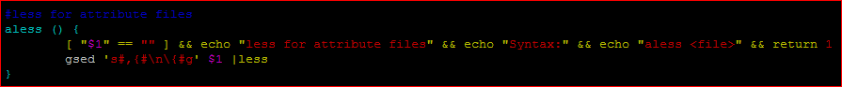

### Example

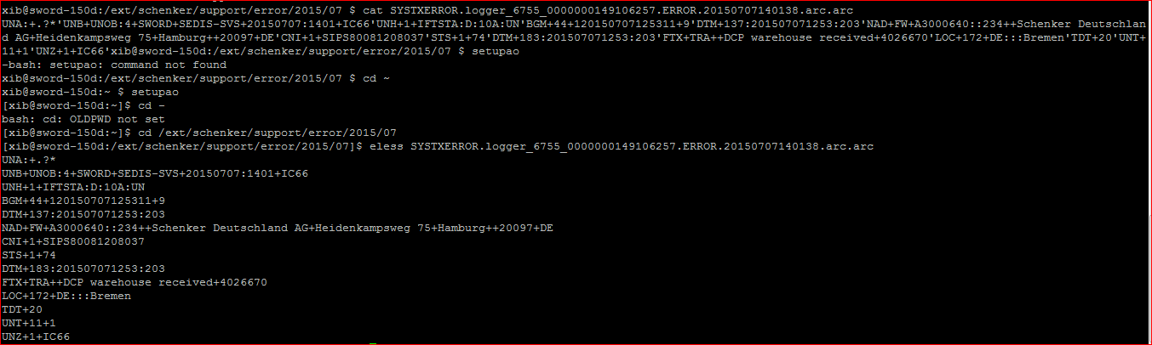

## showloggersize

### Name

showloggersize

### Can be used on

all streams, setupao environment

### Functionality

Pushd and Popd are usually used as pair. Pushd is to switch the current directory to specific directory, and store the current directory into the top of the stack.  
Popd is to switch current directory to the one that stored in the top of the stack, and delete it from the top.

### Details

### Example

xib@sword-151d:~ $ setupao

[xib@sword-151d:~]$ showloggersize

177 778M

6753 803M

6754 815M

6755 1.3G

7929 298M

8251 512M

8622 226M

8623 418M

8624 227M

8629 85M

8630 85M

8631 85M

8632 85M

9422 221M

9423 332M

9424 342M

10303 524M

10304 827M

10305 371M

10306 382M

10307 203M

10308 211M

10309 300M

10417 2.7G

10522 42M

10523 42M

10524 42M

10703 2.9G

10704 2.9G

## showqueuelengths

### Name

showqueuelengths

### Can be used on

all streams, setupao environment

### Functionality

Show the length/file numbers in every queue(under /ext/xib/data/queue]).

### Details

### Example

[xib@sword-151d:/ext/xib/data/queue]$ showqueuelengths

/ext/xib/data/queue/: 1204

/ext/xib/data/queue/179: 665

/ext/xib/data/queue/7930: 313

/ext/xib/data/queue/8252: 49

/ext/xib/data/queue/8732: 92

/ext/xib/data/queue/8822: 85

## showactiveagreements

### Name

show activeagreements

### Can be used on

all streams, setupao environment

### Functionality

With the customer code of 4 letters, this cmd is used to show all active agreements for a customer, no matter what runMode is. As this cmd would browse all the comsys directories, it’s gonna take a while.

### Details

### Example

[xib@sword-157d:~]$ showactiveagreements HPSB

browsing ComSys, please stand by...

/ext/comsys1001/agr/HPSBAOFOXC2_inbound

/ext/comsys1001/agr/HPSBAOFOXC_inbound

/ext/comsys1002/agr/HPSBAIFOXC_outbound

## Count file numbers in sub folder

### Name

gfind

### Can be used on

All Servers

### Functionality

count file numbers

### Details

[xib@sword-182d:/ext/schenker/tmp]$ gfind /ext/schenker/tmp -type f | sed 's#\(.*/\)\(.*\)#\1#' | sort | uniq -c | sort -nk1

### Example



## split and resend big file

### Name

mysplit.sh (in folder: /ext/schenker/support/allen/big_file)

### Can be used on

All gateway servers

### Functionality

Split big file into small ones; resend small files; check log after resend

### Details



### How to use

1. Copy big file to /ext/schenker/support/allen/big_file from error folder.
2. Change folder by using command “cd /ext/schenker/support/allen/big_file“.
3. Excute script by using command "./mysplit.sh <filename>“.
4. Follow the script. Check the line start with [Check], Input when the line start with [Input].
5. House keeping the file in error folder.

### Examples

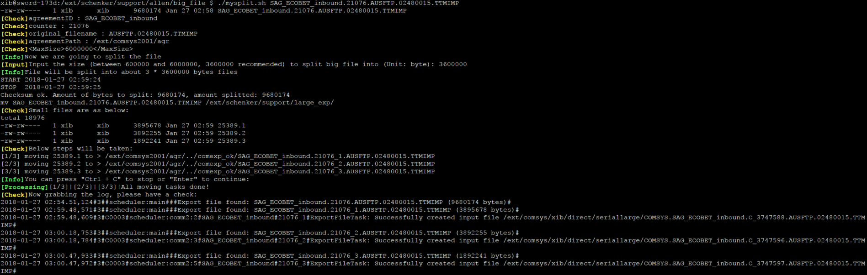

### Exceptions can cause popup

1. No big file name input
2. No file found according to the input file name
3. Agreement path not found according to agreement id from filename
4. The split size manually input is bigger than maxsize or smaller than 10% of maxsize or not a number at all
5. Only one file generated after msplit
6. One or more files bigger than maxsize after excuting msplit